6982488 Corporal Frank Rowley 1st Battalion Royal Irish Fusiliers

“I had to be awkward and got hit in the place I usually reserve for sitting on…”

by Helen James
A few months ago and wearing my hat as editor of the MCS newsletter, I tried a small experiment in my search for unrecorded accounts of veterans of the Italian Campaign. Recognising that like me, most fellow members of our local U3A are of the ‘certain age’ with reference to immediate descendants of those veterans, I addressed the gathering at our monthly meeting, briefly outlining my purpose and asking anyone who may have information about a family connection to the Italian Campaign to contact me afterwards.
It was interesting that out of a hall of 60 people, no less than 6 (10%) approached me afterwards with anecdotes, including the amazing offer from a lady called Carolyn to lend me a package containing all the letters written by her uncle to his family while he was a Prisoner of War (PW) in Italy.
For 80 years the letters had remained unread, eventually being discovered while clearing her parents’ attic, and Carolyn had grown up believing the family story that this uncle she knew well, but who never talked of his wartime experiences, had been a PW.
Reading through the letters for the first time before she passed them on to me, she was shocked to discover that this was never the case, and a very different story has emerged, which I have since pieced together from his letters home:
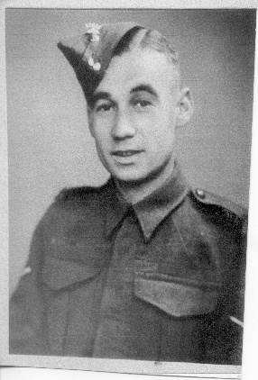
Frank Rowley was born in 1913 in Gedling, Nottinghamshire, and worked at his brother-in-law’s box factory before being conscripted in 1940, when he joined the Royal Irish Fusiliers. After two years of training at various camps in Wales, Frank was posted to the 1st Battalion Royal Irish Fusiliers (1 RIrF) and left Liverpool on 22nd November 1942 aboard Ship No P3, eventually disembarking in Egypt on 11th December 42, where he wrote:

“I have my feet on good earth again and very thankful for it…I am in North Africa, that is all we can say…”

Frank wrote home regularly, but Army routine, boredom and heavy censorship of correspondence meant that most of his letters were inevitably filled with family chat, talk of food, weather and other mundane things. But on 6th May 43 he wrote from 95 General Hospital British North African Force (BNAF) that he had been in hospital for a month after receiving what was clearly a substantial wound, almost certainly sustained during 78 Infantry Division’s operation to clear the enemy from high ground north of the Beja-Medjez el Bab road in Tunisia on 7th April 43. He wrote:

“I had to be awkward and got hit in the place I usually reserve for sitting on. Still, I have my tummy and one side left to lie on, so really can’t grumble.”

Frank clearly made light of the seriousness of the action and his resulting injury, writing on 24th May 43:

“I have unfortunately received no permanent disability, so shall be OK to continue the fight…Glad you got my Field Card (posted on 5th April 43), as you say, it was posted two days before I was smacked, I knew we were going into a pretty big show and I didn’t have a chance to write…and wanted you to know that I was OK up to April 5th, still…I was lucky and have suffered no serious harm… but at the moment I am afraid I should just jump out of my skin at the noise of the bombs, I think if I ever see a Stuka again I should pass out with fright…”

The injury to Frank’s thigh was to see him out of action for several months, and in a letter written on 11th July 43 from 8 Convalescent Depot BNAF, he wrote:

“… I am about OK now, just a question of getting the muscles in the bottom of my back and my leg working again, I had a good slice carved out of me, I still marvel that it hit me where it did, about the only place I could stand a flesh wound of any description...
… As you know, I was almost 4 months in the fighting here, and in that time never came out for rest, it was a horrible experience, and one that I hate to think I shall have to repeat. The news of the Allied landings in Sicily makes it almost certain that I shall see action again in the near future … I have been lucky once and come through, but realize (sic) that it can’t always be “the other fellow” that gets it. I hope that for my sake and my people at home that I am as lucky again …”

The letters from 8 Convalescent Depot BNAF convey some of his feelings and misgivings, combined with a certain air of resignation about returning to the conflict.

6th August 43. “… I do not suppose I shall be here much more than about a fortnight now, so hope the boys have made a job of Sicily before I go from here, I had a tummy full of this lot. Still, I suppose I have a lot more of it to see in some country or other. I only know that I never felt less warlike than I do now.”

18th August 43. “… the news seems to be very good just lately, the Sicily show is nearly over and old Joe Stalin is showing them the way home. It may be the beginning of the end, or is that wishful thinking?... touch wood I am now completely healed up, hope it doesn’t break out again...”

30th August 43. “… as you say, I shall soon be going back to the mob….The war seems to be doing pretty well now, I think if I can keep on top of the ground for about 12 months, I shall about see the end of it; he is certainly taking a bashing from the Russians now, and every one they knock off is one less for us…
… Everyone is wondering what now? ...”

4th October 43. “… There are a couple of friends of mine in the camp here, both Cpls from the Battalion ... one of them was hit the same day as me but recovered and went back to the mob just before Sicily, where he caught another one, not bad, just enough to put him in dock awhile. The other bloke is really lucky, he has hardly any use in his left hand and is waiting to go home, needless to say either of us would change places with him were it possible …”

Frank spent eight months recovering from injury, but on 11th December 43 he wrote that he was back with C Company, 1 RIfF and now in Italy. The 1 RIrF War Diary records that October had seen them involved in heavy fighting at Termoli and on the River Trigno, but he doesn’t mention this, preferring instead to write about his billeting situation:

10th January 44. “… Italy isn’t a bit like I thought it would be, at least this part of Italy. At the moment we are back for a rest, and I along with 3 other fellows are billeted in an Italian house. Try and imagine it, the room downstairs is about 8’ wide at the most, the room upstairs must be the same, I have not been up to have a look as the pink-cheeked Signora might object. The floor is rough broken stones, all rough and uneven like a crazy paving, the only light that comes in is through the open door, this has of course to be open all day, there are umpteen feet of snow outside, which adds as you may guess to the cozyness (sic) of the room, the floor is all wet and muddy. All morning over the wood fire, there has been brewing a big copper pot, into which from time to time many strange things have gone. I was able to identify small potatoes, onions, spaghetti and some form of beans, the rest of the things were strange to me. The brew is ready, it is all stewed up in a big pot dish and placed on a table about 1’6” by 2’0”, chairs are placed at and near the table, 4 women, 1 man and 2 small children, all are armed with forks, I and the other 3 fellows are offered forks, which as you can imagine are politely declined (we having watched this pot all morning), smiles and a lot of sign language are exchanged, the family feed all dipping their forks in the one pot. The stuff when finished is stiff, enabling it to be eaten by a fork. Sanitation is non-existent, and the women draw water from the centre of the village. I suppose it is a spring piped into big troughs. The sheep, the goats, cattle and mules are all taken there to be watered, the women also wash clothes there, and the army or at least C Company wash and shave there. It is surprising how clean the women get the clothes in the cold water, but I think they use some form of strong bleach, at least at Xmas I had a drink from a bottle (taken by mistake) which I was told next morning contained spirits for washing clothes, I know I nearly choked…”
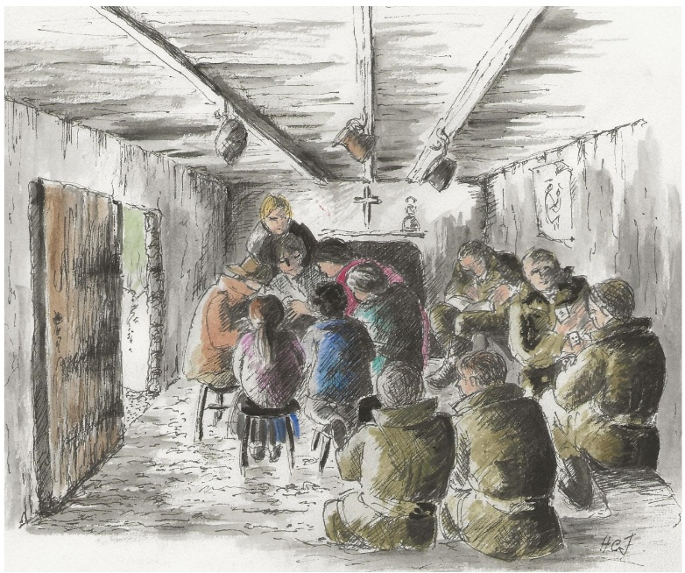
27th January 44. “… I am writing again from the civvy house I described to you before, the only difference is that this time there are 5 of us billeted here, this is the second time I have been billeted here and we look forward to these rests, it enables us to get our clothes washed, etc…”

The early months of 1944 were taken up with occasional rest, and intensive training for battle and river crossings on the Volturno in preparation for an eventual Allied breakthrough into the Liri valley. 36 Infantry Brigade moved down from the high Apennines in early February 44, and by April 44 1 RIrF were positioned on the lower slopes of Monte Castellone, near the village of Caira, on the Gustav Line at Cassino.

On 6th May 44, five days before the Fourth Battle of Cassino, Frank wrote:

“… we are back again resting and the weather is lovely, we have gone into K.D. (khaki drill) again, shirts and shorts, and are getting sunburnt. We are in a lovely spot, everything is very green and I think it must be the first time troops have camped around here, everything is very fresh…”

This rest time was short-lived, for the massive build-up to the Fourth Battle of Cassino was well under way, and on 16th May 44 - while the battle was raging, Frank’s words, while putting a somewhat sardonic spin on the situation, could not hide the sheer horror of what he must have been experiencing:

“My beginning is very realistic, the sun is beating down in my particular hole like all hell, and for the last 1½ hours going over my head has been a barrage from 700 guns, mingling with the Organ like sound coming from his lordship’s famous (or infamous) Nebelwerfers, Sobbing Sisters, or Moaning Minnies from the British or American Armies. So all things being considered it’s a lovely spring morning… it is pretty rough going out here, and we are all hoping that it will make him (the Germans) pull out of here, I could then settle down in comfort to enjoy this lovely Italian summer…”
“... the next one (newspaper) will include Termoli, Trigno, Sangro, etc. Names that I think will be famous in this Regiment for all time, and from the look of things we have still a long way to go…You will see that I have now been made a full Sgt…”

The Benedictine Monastery at Cassino was occupied by the Poles on 18th May 44, and the Allies moved slowly and painfully forward up the Liri Valley against heavy opposition. 1 RIrF were engaged in action, and the war was taking its toll on Frank, for on 11th June 44 he wrote from HQ Company:

“… in Bernard’s letter of 28.5.44 he tells me that this last month there have been great doings in Italy. I think most of us confirm that, I have just written to Mother for the first time since the first mad Bash almost a month ago… this last do was like nothing either on earth or in hell, and as you will see I have changed my Company and am now in HQ, the idea being to give me a rest, it was either that or leaving me a few more days when I should have been one of those poor blighters who are led away crying and screaming and shaking. In Army parlance I have definitely “had it” and it will be a while before my nerves settle down again enough to let me have another go…”

On 11th August 44, Frank, now back to being a Corporal, wrote from HQ Company:

“…I shall be going in Hospital, I think within the next few days, most probably a Rehabilitation place, I saw a Specialist just before I went on leave and he said my nerves were pretty bad and I needed a few weeks treatment….”

By 18th August 44, he was writing not from 1 RIrF but from 78 Psychiatric Hospital:

“…you will see that I am in Dock, nothing serious, just nerves out of sorts, but at the moment I feel pretty cheap….”

And on 28th September 44:

“... I saw a Bette Davis picture …all about nerves and psychiatrists, etc, a rum place this to see a film like that…I know I was a long time between letters last time, but we were having a pretty grim time and I have never been either so tired for so long or felt less like writing letters, still I survived and am once again able to enjoy life, I only hope that I never have to go through that lot again…”

In November 44, Frank was moved to Details Company 2nd Battalion Infantry Training Depot in Egypt and wrote that he was feeling much better, hoping to be sent to Base for a job away from the front line, and wondering what Christmas 1944 would be like compared with 1943:

“... Still, I had a good Xmas last year, we were out resting and moved back in on Boxing Day. I shall never forget the months that followed either, we were up at Cassino three times, the second time for 30 days, came out for 9 days and then went in again across the Rapido River on the big push, it’s something to remember, we finished up at the top end of Lake Trasimeno, can you find it on your map, it’s south of Florence…?”

But on 29th January 45, he was writing from R Camp, Base Ordnance Depot Alexandria in Egypt:

“… I have been trying very hard to get away from this country, tried to get to Greece, Italy or India but am very much afraid that I’ve ‘had it’ and seem doomed to stagnate in Egypt until the end of the war … I am definitely feeling OK now, there was never much wrong with me, a slight halting in my speech and a bit of a shake, but I had definitely had enough…”

And on 28th March 45:

“… have seen about every Brass Hat in this place for a move, and my application has now been forwarded to O.2.E. (General Headquarters Second Echelon) so must wait and see what happens… the war seems to be going very well, I would have liked to have been in France (not with an Infantry Battalion) …”

Frank finally left for home at the end of 1945, writing on 4th December 45 from the same camp:

“… Am writing this in Alexandria, just a short letter to let you know I am getting the Boat for home tomorrow morning the 5th. Shall be coming overland through France, so it should take about 10 or 12 days, anyway with average luck I should be home for Xmas.”

He returned to civilian life and work in the box factory, before moving to York in the 1950’s, where he had a Newsagent’s shop, and then a Post Office in Heworth. He married, rebuilt his life, and died in 1991 aged 78, but the narrative maintained by his immediate family and passed down to future generations, was that during the war he had been a PW.

It is obvious from Frank’s letters that he was suffering from “shell shock”, or “PTSD” as the condition is now known. Fortunately for him this was recognised, he was removed from front line action and treatment was available, but what seems incredibly sad is that for 80 years the lie had persisted that he had been a PW and not a brave veteran deserving of respect, who had fought and endured severe physical and mental harm in some of the most terrifying military engagements of the Second World War.

In his letters Frank emphasised the positives, often implying that things were not as bad as they might seem, and only occasionally revealing how frightened he really felt, in an effort to spare the feelings of those at home. It appears that on his return he must have either directed the family to adopt the PW myth or at least accepted that this was an easier way for them all to deal with any questions arising about his war service.

Hindsight is a wonderful thing, and we know from countless Veterans’ recall of their return to civilian life and a population exhausted by war, that it was, and remains difficult (often impossible) to adjust to the ‘new normal’ for all concerned. Many veterans, aware of a general lack of interest in what they had experienced, remember their desire at the time ‘not to talk about it’, to ‘put it all behind them’ and ‘look forward to the future’.

We might accept that in this environment, Frank found it easier to go along with the PW story, but it is undeniable that even to this day more than 80 years later, the social stigma attached to mental illness remains a glaring issue in society as a whole, with traumatised veterans of more recent conflicts experiencing the same apathetic attitude on their return home. Frank’s family, who from Carolyn’s description were close and caring, may well have felt some of this ‘shame’ and found it more convenient to reinvent him as a PW to explain his absence from active service for months at a time.

Revisiting Frank’s correspondence has been a revelation for his family. Frank and his parents’ generation are long gone, taking the family secret with them, so we can only guess at the reasons behind the lie, but his story deserves to be told. It has been a privilege to read the letters with his description of service in the Tunisian and Italian Campaigns, and his personal journey through injury to recovery.

With grateful thanks to Carolyn Baines.

Helen James 2026

